Pre-Reading

Punishment
The first new structure that we will see is “___和__在一起” (zai4yi4qi3) This phrase means something and something together, or in English we would just say “together.” 比如 (remember this means “for example”), 妹妹和妈妈在一起, which means “littler sister and mother are together.” The next word is 过来(guo4lai2) should be seen with 过去 (guo4qu4), the first one 过来, means to come here. 比如 “你过来！” means “you come here!” but this may sound a little rude, so be careful who you use it with. The other one, 过去 means that the person goes toward something or someone, so they basically have the same meaning but it depends on the perspective of the person. 比如 “我过去” means “I will come over.” In the next sentence, the writer’s mother uses the phrase 一定 (yi2ding4), which means for sure, not changing. So you could say, “我一定做作业” (wo3yi2ding4zuo4zuo4ye4) or I will do my homework for sure. The next word 抓住(zhua1zhu), the first character 抓 is made of a left and right radical, the left radical is a hand radical, it tells you that the character has something to do with your hand. 抓 means to grab, the second character 住 can mean “to live” but here it combines with 抓 to mean that she actually grabs a hold of something. The 住 signifies that the action was complete and will that it will continue. The next word 以后 (yi3hou4) simply means after. The next word is 惩罚(cheng2fa2), which means punishment. The first word 惩, remember this character by remembering the top radical as 征 which means conquer and the bottom as 心, which is heart. The other character 罚 also means punishment. The author uses the word 要(yao4) a few times, this can mean want, as in 我要钱 (wo3yao4qian2) I want money, or it can be used as future tense, will. For example, 我要杀他 (wo3yao4sha1ta1) I will kill him, but this could also mean want… depending on the context. Following this the mother lists a few punishments that she has in mind. The first is 打扫 (da3sao3), which is the generic word for clean. If you notice both words have the hand radical, and you may remember that 打 here means to hit or to play, here when it is added with 扫（sweep）it means to clean. So you could say 打扫教室, which is clean the classroom. The next punishment is 拖地板 (tuo1di4ban3), the first character 拖 again has the hand radical, but here this character means mop. So you might guess that 地板means floor, the first character地 literally means ground and the second板means board. The next word is 擦洗 (ca1xi3), the first character again has the hand radical, thus it is very similar to the other characters, however this one means scrub. The second character洗 is to wash, you can see the radical on the left has three dots, those dots indicate water. So here we are scrubbing with water and the object is the 窗户 (chuang1hu4), the first character 窗 is a pictograph of a house (the top part) and the window (the bottom square), so 窗户is window. Finally, the mother says the thief, will 后悔 (hou4hui3), which is regret.
Story Character Count = 70

Vocabulary/Writing
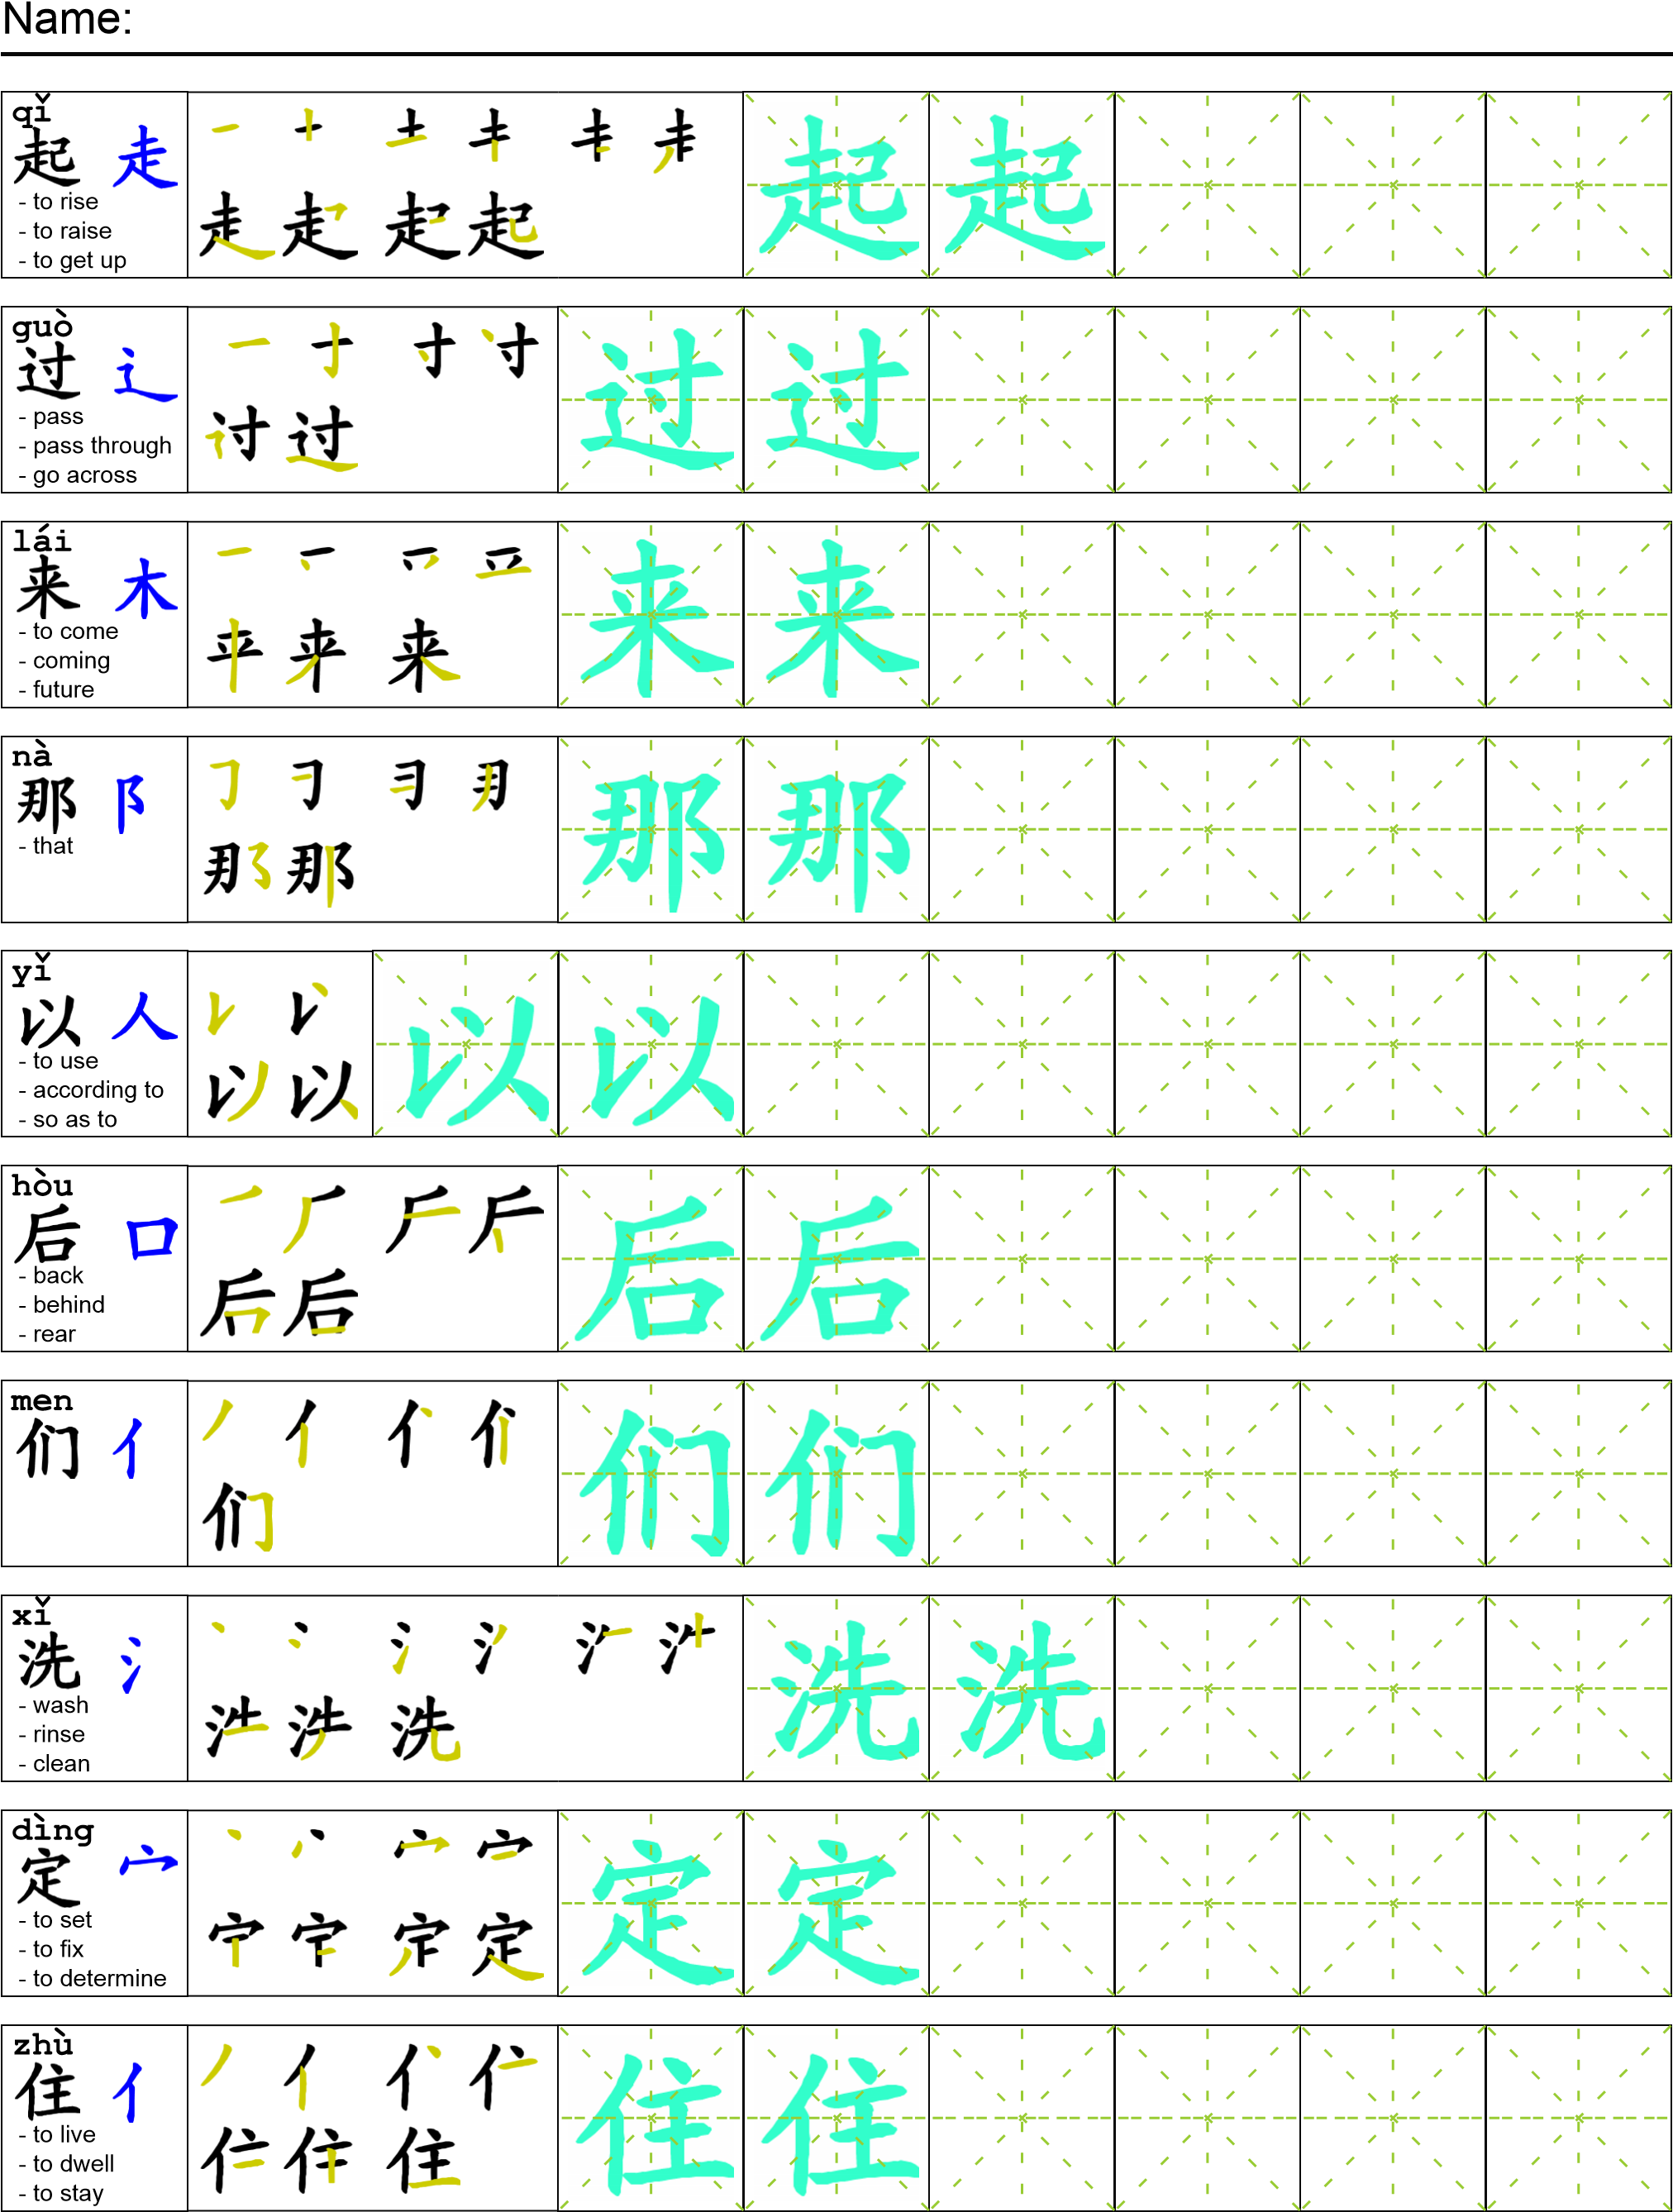
Reading

我妈妈看到我和我妹妹在一起。她过来了说“我一定要抓住那个小偷！抓住了以后我会惩罚他！”我们说“什么惩罚？”她说“打扫厕所！拖地板！擦洗窗户！他一定要后悔他偷了东西！”

Task Completion

Once all tasks are complete turn the assignment in to collect the points for the project.
Task 1: Trace the vocabulary and copy the text into your notebook.

Task 2: Answer Comprehension Questions.

Task 3: Write the Pinyin for the Reading.

Task 4: Translate the Reading into English.

Task 5: Record yourself reading the passage.

Comprehension Questions
- Write the Chinese for two of the punishments suggested by the mother.
- What word should we compare过来with? Why?
- How does the mother express a certainty?

